**Student: Kim Bomin**

**Student ID: 2020310050**

**FINAL PROJECT PROPOSAL**

**[SKKU PROJECT EXHIBITION]**

**Project context and Goals**

I am planning to produce a page that displays the projects that our school students wrote in class. You can collect projects by subject and subject, and there is also an exploration button that allows you to look around the project randomly.

**Plan**

1. Front-end: React, local storage

- html, css, scss, js, jsx((JavaScript XML) files

1. Back-end: express
2. Database: MySQL, Folder
3. Package manager: npm(node package manager)

**Page Configuration: 7 pages**

1. Register page

* input name, student Id, password, (+email)
* Check id duplicate

1. Login page

- input id, password

1. Header: logo, page list, welcome message
2. Footer: page description, github link, skku link
3. Body
   1. Main page: show wordcloud(keyword of each project)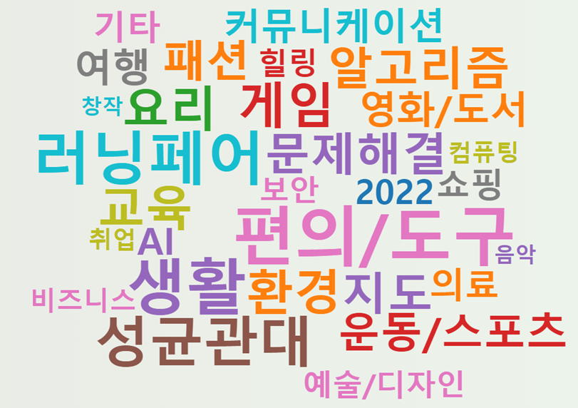
   2. Each class page: minimum 5 page
      1. You can view the project overview divided by class.
   3. Each hashtag page: minimum 10 page
      1. You can view the project overview divided by hashtag(keyword).
   4. Project detail page: minimum 30 page
      1. The detailed project page consists of the project title, description, team name, team member name, image file, hashtag, and number of likes
   5. (Add when available) Upload page
      1. You can upload project information

**Similar Existing Solutions**

Online project exhibitions will be held at the end of the semester in the first grade essential liberal arts lectures. The page was motifed.